Procedure for LEP identification and placement

The OMSIS report (2020) identified 92% of the migrant students in the state of Oregon as being Hispanic, many of whom are predominantly Spanish speakers. For ELLs, instruction only in English subtracts from their culture and daily life experiences. Not surprisingly, Oregon high school students with limited English only gain a 60.2% on-time graduation rate. Because of the state’s dependency on agriculture and need for MSFW, combined with the state’s lack of educational resources in Spanish, TVCC HEP’s capacity to provide instruction in both English and Spanish provides educational opportunity not provided elsewhere.

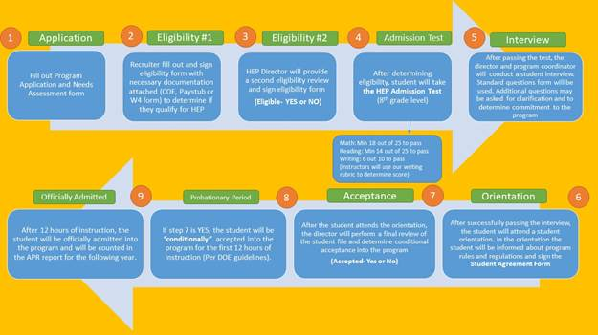

- Summary of steps taken to increase LEP participation in programs where they traditionally have been underrepresented

Outreach & recruitment - TVCC HEP recruitment plan target MSFW students by conducting special informational workshops at migrant educational programs and community-based organizations. TVCC HEP has been distributing several public service announcements in English and Spanish. Outreach materials are designed in Spanish and English.

Skill assessment - Each eligible participant takes a standardized diagnostic assessment to determine if the student has the basic reading level (6th grade) and math skills (7th grade level) necessary to progress through the course. The assessment also assists HEP staff to determine the areas where the student needs significant attention.

Academic support - TVCC HEP provide instruction in English and Spanish by experienced instructors. The academic support incorporates the use of computers in instruction and testing. Tutors are available for the students, and staff review each student’s academic progress in a monthly base.

Career Discovery and Exploration - TVCC HEP help students with career discovery, exploration, and planning. A HEP student who is completing a GED do some exploration before entering the workforce and work on the necessary job readiness skill and/or a Career Pathway offered at TVCC.

Supportive Services - TVCC HEP provide exposure to cultural events, academic programs, and other educational and cultural activities usually not available to the migrant community. Also, the program provides innovative and responsive follow-up services for GED earners. GED earners will take part in advising and career planning, learn about transfer and vocational programs, explore career and military options, and earn priority placement in ESL or other post-GED courses.

Financial services - To maximize financial aid services, TVCC HEP work closely with the Office of Financial Aid to provide FAFSA workshops, scholarship opportunities, and connect graduated HEP students to potential admission at TVCC. Also, TVCC HEP connect with the TVCC Foundation Office for additional financial support services when a HEP student is admitted at TVCC.

Placement services - TVCC HEP partner with the TVCC CTE. CTE provides Tech Prep option for those students seeking an associate degree in a Career and Technical field. HEP students have the option to enroll in this program after they receive their GED. TVCC HEP also collaborate with the Oregon Human Development Corporation (OHDC), Oregon Department of Human Services - Ontario, Oregon Department of Labor- WorkSource - Ontario, Idaho Department of Labor, and Community Council of Idaho to help students with career discovery, exploration and planning.

