TVCC Recruitment Plan
Treasure Valley Community College, Admissions Office
This plan was created to assist in documenting the planning, efforts and results that are being made to address the Strategic Direction for enrollment, as outlined in the President’s Vision. The detailed President’s Vision for enrollment and program growth can be found HERE.

The President’s Vision in Summary:
- Make TVCC the first choice for students;
- Focus on enrollment growth strategies;
- Increase efforts to promote a positive college public image;
- Advance internal communication and connections
- Cultivate diversity and cultural opportunities; and
- Promote safety and security across campus.
Additionally, the President has identified the goal of increasing TVCC’s Reimbursable FTE by 2% annually off of 2018-2019 Enrollment Numbers through 2025.
It is the goal of this three-year recruiting plan to outline a tactical approach to the activities that must be completed by the staff in the Admissions Office. Data collection is necessary to ensure the Admission Office staff are making informed decisions based on data and that the planning, efforts and assessment of those efforts provide the direction for future years.
It is also acknowledged that the Admissions Office, and other departments on campus, complete other projects and initiatives during the year that may not be specifically outline in this document.
CONTENTS
TARGET MARKET 2
ADMISSIONS AND RECRUITING PRIORITIES (1-3 YEAR) 3
ACADEMICS & CTE PRIORITIES (1-3 YEARS) 5
SIGNATURE CAMPUS ADMISSIONS EVENTS 7
SUPPLEMENTAL INFORMATION 8
FALL 2018 MATRICULATION FUNNELL 8
COMMUNICATION MANAGEMENT 8
CAMPUS VISIT MATRICULATION FUNNEL 10
NEW DEGREE SEEKERS REPORT 11
NEW DEGREE SEEKERS BY HIGH SCHOOL 12

TARGET MARKET
The TVCC Admissions and Recruiting Office specifically targets students from Oregon and Idaho. In addition, states adjacent to Oregon and Idaho are targeted through other sources of recruitment and inquiry services.

The Traditional Student
The majority of our recruiting efforts are focused on the traditional pre-college student, both first-time and transfer students age 24 and under. Currently, the primary focus on the majority of our recruiting efforts and resources are targeted on this student population.

The Non-Traditional/Transfer Student
Non-traditional students can include first-time and transfer students, 25 and over, who have families, students who have full-time work commitments, etc.
The primary goal of recruiting this student is to market TVCC as the first choice for professional advancement, development and retraining opportunities within the communities we serve.

Student Characteristics
TVCC recognizes the ethnically diverse demographics within the surrounding areas of the communities we serve. Below is the characteristics of our Fall 2018 student population as presented in TVCC’s Fall 2018 Integrated Postsecondary Education Data System (IPEDS) report.
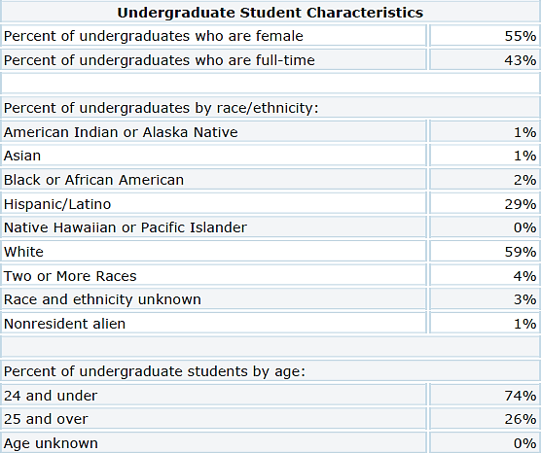

ADMISSIONS AND RECRUITING PRIORITIES (1-3 YEAR)
PRE-ENROLLMENT EXPERIENCE

- Review all steps in the pre-enrollment process in order to reduce barriers and enhance satisfaction as prospective students progress from Inquiry > Admit> Registered.
  - Continually analyze the annual admissions funnel and conversion rates. HERE, is the 2018 baseline matriculation funnel from Enrollment RX.
  - Analyze results of the annual student survey to identify ways of improving the pre-enrollment process.
  - Review automated responses through Enrollment RX and Pardot regarding student progress through admissions, testing, advisement, registration, financial aid, payment, orientation and enrollment (See Communication Management).
  - Present the communication plan in place for prospects campus wide.
  - Develop baseline data to illustrate TVCC’s recruitment funnel in order to research and identify effective strategies for improving the conversion from one status to the next.

Increase the involvement of faculty and academic departments in the recruitment process.
  - Increase faculty participation opportunities when recruitment opportunities present themselves.
  - Work with faculty to design faculty communication for specific department highlight to potential students and even High School Counselors.

Increase the satisfaction of the Campus Tour process.
  - Continually analyze the importance of campus tours and matriculation funnels to a registered student. HERE, our campus visit matriculation rates from 1/1/2018 to 8/12/2019 can be found in the supplemental information.
  - Assess the ease to register for a campus tour and communication leading up to the registered time.
  - Develop, administer and analyze a post-tour survey regarding satisfaction and areas for improvement or to highlight in the future.
RESEARCH

- Develop and sustain tracking data collecting of enrollment patters and trends in order to develop targeted recruitment strategies
  - Development of a Quarter to Quarter Comparison Report of First-Time Transfer Students to predict trends and measure current recruitment impact. HERE, is an example of such report provided by TVCC’s Office of Institutional Research.
  - Continually analyze enrollment numbers for the previous 3 years sorted by campus and year.
  - Work with the Academics to identify future program development.

Develop a historical profile of high school yields in order to research reasons for yield rates and strategies for maximizing enrollment.
  - Identify local High Schools in Malheur, Washington and Payette County in regards to graduating seniors and the number of those students enrolling. HERE, is an example of such report provided by TVCC’s Office of Institutional Research.
  - Examine the history of individual High School yields and identify schools where yield has dropped or traditionally low. Focus on bringing the applicant pool up and increasing yield.

    - When an individual High School has been identified, the development of an action plan to strengthen the relationship with that High School will be develop on a unique case-by- case scenario.

Analyze and review annually TVCC’s strengths, weaknesses, opportunities and threats, and make recommendations for reactions.
  - Use more focused campaigns for recruiting events and venues in ERX.
  - Assess the success of all outreach activities and yield analyses.
    - Outreach activities are defined as events or activities TVCC represents itself in that has a specific impact on the on the recruitment of students.
  - Utilize the TVCC Initiative Assessment Form for Campaign Analysis.

THE TRADITIONAL STUDENT

- Focus on and enhance relationships with the High School community.
  - Design more opportunities for prospective High School students to attend and experience campus life through Signature Campus Admissions Events. HERE is an example of the Annual Signature Campus Events being promoted through the Admissions Office.
  - Identify targeted messaging and Faculty who are willing to reach out to prospective High School Students.
  - Create and sustain connections with School Administrators and Counselors with TVCC Administration and Professional Staff.
  - Provide additional speaking services related to college readiness (i.e. FAFSA Nights, College App Nights, College Engagement and Readiness, etc.)

Develop strategies to attract a greater number of high academic achievers into the incoming class.
  - GPA Advantages/Incentives
  - Promote Scholarships through the Foundation
  - Incentivize Summer Registration for incoming Freshman

Increase the overall yield from Malheur, Washington and Payette County High Schools.
  - Emphasize campus life
    - Involve Student Life, Residence Life, Athletics and Other departments presentations and activities.
    - Use Signature Campus Admissions Events as opportunities to forge stronger links with school districts.
  - Develop a TVCC steps to success poster specifically to promote programs of study and enrollment.
  - Invite applicants and inquiries to attend Signature Campus Admissions Events.

Appropriately identify Dual Credit/Col-Credit students currently taking TVCC courses in High School and increasing the yield of those students.
  - Identify and incentivize higher GPA students to finish their Associates Degree or program of interest at TVCC.
  - Develop a TVCC initiative and poster regarding steps to completion through the concepts of a general “road-map” to college success, to share with area High Schools and Current TVCC Students.

NON-TRADITIONAL/TRANSFER STUDENT

- Expand initiatives designed to develop the perception among adult students of TVCC as the first choice for professional advancement, development and retraining.
  - Continually review and evaluate event times and days in order to accommodate our students who also have current employment.
  - Promote resources to targeted adult learners and information on CLEP, Testing, Clubs, community resources, etc.
  - Evaluate the expansion of evening and weekend hours, as well as online, for classes and services.
CULTURALLY DIVERSE STUDENTS

- Expand special recruitment activities which focus on increasing the diversity of the student body.
  - TVCC will work to leverage our current CAMP and HEP grants to assist in the recruitment of diverse student populations.
  - Involve Directors and Coordinators of multi-cultural affairs and services in recruiting activities and opportunities.
  - Review opportunities for providing bi-lingual literature.
  - Highlight Cultural Awareness events on campus and promote community attendance to those events.
  - Integrate a Signature Campus Admissions Event with opportunities for culturally diverse student populations within TVCC, the community and future education opportunities.
  - Increase outreach to prospective international students.
ACADEMICS & CTE PRIORITIES (1-3 YEARS)

In line with the President’s Vision the following Curriculum Development has been identified specifically under the following areas:
- Automated Controls System Enhanced
- Welding (evening and day)
- Computer Technology
- Natural Resources Growth
- Ag-Crops
- Consult with Industry
- Criminal Justice
- Addiction Studies
- Revise Computer Information Systems
Academic Transfer and CTE will affect overall enrollments with the addition of new programs, which include:

- Welding in Caldwell. Currently, Welding courses are only offered in Ontario. First-year welding courses will run out of the Caldwell Center, utilizing a partner welding facility. TVCC has provided welding equipment, on loan, to the new charter high school, Elevate Academy. Part of this partnership allows TVCC to use their facilities in the evening. (Expected 1.5 FTE, non-reimbursable).
- Cybersecurity track for the CIS program. TVCC has completed work to begin a new track, designed to jump start the enrollment for its computer science program. (Expected 0.5 FTE, reimbursable).

Although not an academic program, the new STEP program is anticipating serving 75 distinct students over the course of 2019-20. The focus for enrollments for STEP participants is CTE and Workforce training; however, academic transfer paths are allowable. (Expected 10 FTE, reimbursable)

In addition to new programs, TVCC is also expanding the reach of existing programs, specifically Industrial Manufacturing and Controls program (IMAC), with additional dual enrolled, dual-credit students. This specific expansion began softly in 2018-19, Spring term, when faculty began a partnership with Union HS in Nampa, ID. The Spring term course, Intro to Automation, was introduced at UHS, with 10 students enrolled. Due to the success of the partnership, UHS would like to run a course during Fall, 2019-20, and another course in the series in Spring, with expanded amount of students in both (15-20 students per course). The funding for this model comes from Idaho’s Advanced Opportunities program, which pays the rate of $65 per credit per student. More importantly, the model builds pipeline for the program in the future. (Expected 2 FTE, non-reimbursable).

Finally, Wilder Middle-High School would also like to replicate the Union HS model. The bottleneck to expand this model to Wilder, and any other location, is the availability of qualified adjunct instructors. If TVCC is able to obtain qualified instructors, we will expand this model to Wilder, during 2019-20. (Not expected but would be 0.5 FTE – non-reimbursable).

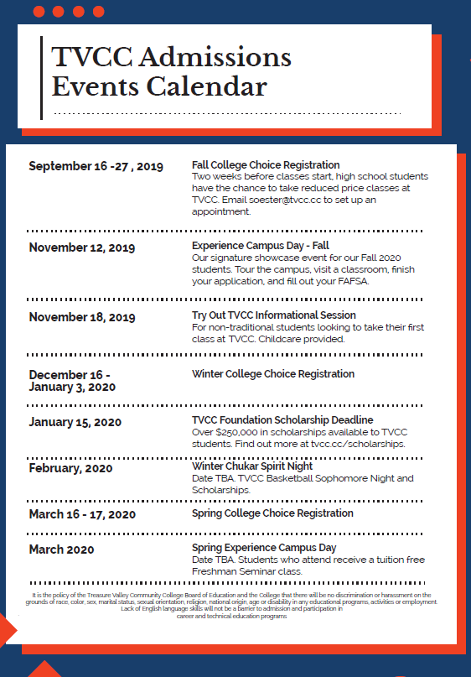
SIGNATURE CAMPUS ADMISSIONS EVENTS

Over the course of the 2018-2019 academic year, the Admissions Office aggressively developed a number of campus and events and initiatives to address enrollment growth. These initiatives proved successful and involved a high level of interested on and off campus. Building off this interest, the TVCC Admissions Office has developed
a yearly calendar of TVCC sponsored Admissions events, in addition to other important college sponsored initiatives, that can be expected annually, with specific targeted student populations. Adjacently, is an example of the upcoming 2019-2020 Signature Admissions Events being planned and promoted.

*The presented events do not reflect the number of other events TVCC Recruiters and Representatives attended, such as High School and Industry Visits, FASFA Nights, College Application events, College Fairs, etc.

SUPPLEMENTAL INFORMATION

FALL 2018 MATRICULATION FUNNELL
The following represents the number of Inquiries, Admits, Registered, Closed accounts and Other for the Fall 2018 Academic Quarter.
*Note: this report was generated from Salesforce/Enrollment RX and is not directly from TVCC’s Jenzebar Database.

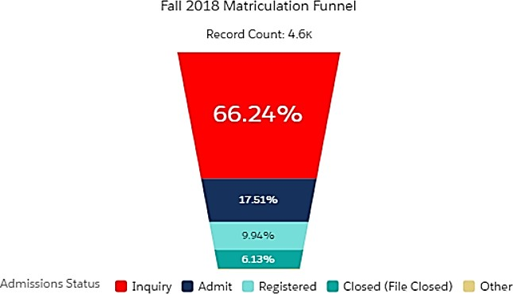

COMMUNICATION MANAGEMENT
Prospective student communication and student contact management refers to the communication process used in the recruitment of a student. The goal of this process is to assist in providing all information needed to further a student’s decision to apply and enroll to Treasure Valley Community College. Once a prospective student shows interest in TVCC they are entered in to our database driven communication plan through Enrollment RX/Pardot managed through the Recruiting Department. The steps below, outline the process.
Recruit/Inquiry Communication Plan

The purpose of the recruit/inquiry communication plan is to drive the inquiry/recruit to submit an application for admission. Once the student has applied to TVCC, they are taken out of the Recruit/Inquiry Communication Plan and they are then added to the Applicant Communication Plan.

Step 1: Upon the receipt of an on-line or in-person inquiry form. The inquiry immediately receives an email “Thank you for your inquiry”.
Step 2: A “Call Inquiry” tasked is created and assigned to the contacts primary contact owner in Salesforce and a follow up call will be placed approximately 5 business days after the delivery of Step 1.
Step 3: Approximately five (5) days later, the inquiry receives the “Tuition & Fees” email.
Step 4: Approximately five (5) days later, the inquiry receives the “Apply for Admissions” email.
Step 5: Approximately five (5) days later, the inquiry receives the “Learning at TVCC” email which encourages inquires to speak with an Academic Advisor if they have questions regarding specific programs.
Step 6: Approximately five (5) days later, the inquiry receives the “Schedule a Campus Visit” email.
Step 7: Approximately five (5) days later, the inquiry received the “Student Success at TVCC” email. This covers Student Leadership, Athletics, On-Campus Housing, and other recent things going happening on campus.
Step 8: Approximately five (5) days later, a call task is assigned to the contact owner to encourage the inquiry to apply.
Applicant Communication Plan

The purpose of the Application Communication plan is to aid the applicant through the admissions process and increase yield from Admit to Registered status. The Recruitment office is always looking for ways to improve our automated driven communication plan.

Step 1: Application Letter and Personal Contact. Once a student applies they are sent a letter notifying them of their admittance. Along with the letter, our “Next Steps” and College Calendar are mailed to them with the same letter. Once the student has reached Admit status in Enrollment RX, an “Congratulations on your Admission” Email and a personal call from their contact owner within five (5) business days.
From this point further, there are a number of variable communication paths the student may receive automated messages on based on answers within their application and date of submission. The remaining process is an example of a “Traditional” student’s communication Plan who has applied in the Fall of their Senior Year in High School.
Step 2: Wait twelve (12) days and the “FAFSA” email is sent.
Step 3: Wait fourteen (14) days and the “TVCC Foundation” email is sent. Step 4: Wait fourteen (14) days and the “College Transcripts” email is sent. Step 5: Wait fourteen (14) days and the “Placement Test” email is sent.
Step 6: Wait fourteen (14) days and the “Housing and Meals” email is sent.

Step 7: Wait fourteen (14) days and the “Student Leadership” email is sent. Step 8: Wait fourteen (14) days and the “Athletic” email is sent.
Step 9: Wait fourteen (14) days and the “TVCC Resources” email is sent. (See Strategies for Improving Admit to Registered students)

Special Communication Plan and Timeline:
In addition to automated communication’s there are a number of unique communications that are sent to student’s vial mail, call, text and list emails. These unique communications are dependent on the time of year and student’s status. This can include, but are not limited to: Scholarship Opportunities, Degree Specific Information Sessions, Orientations, Advising and Registration, Special Events, etc.

CAMPUS VISIT MATRICULATION FUNNEL
Below is a visual summary of the matriculation of students who have attended a campus visit and their conversion to registered student. As of August 12, 2019, 30.66% of students who attend a campus visit become registered TVCC students at TVCC. Given the timing of this report, we expect this rate to grow once the Fall 2019 quarter has commenced.
*Note: this report was generated from Salesforce/Enrollment RX and is not directly from TVCC’s Jenzebar Database.

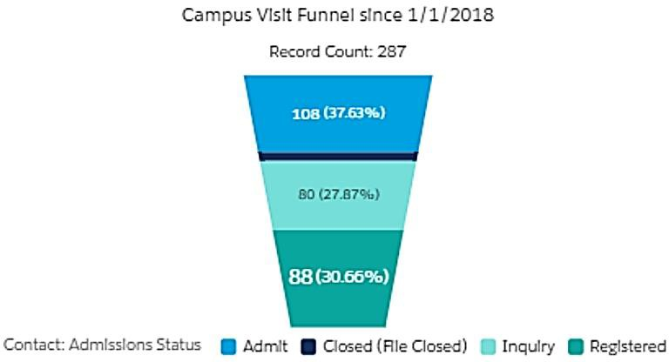

NEW DEGREE SEEKERS REPORT
The following is an example of the New Degree Seekers report being utilized to track recruitment efforts of new students. The quarter below is comparing the Summer 2018 quarter to the Summer 2019 quarter as of August 12, 2019.
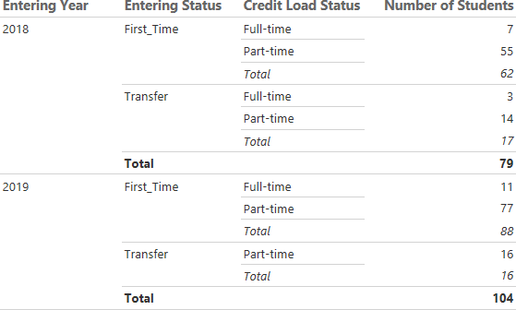

NEW DEGREE SEEKERS BY HIGH SCHOOL
The following is a visual of TVCC’s Fall 2018 first time students (ages 21 and younger) and their correlating High School they attended. By tracking this information, it will allow TVCC to identify our top feeder High Schools and identify High Schools where there may be recruitment opportunities.
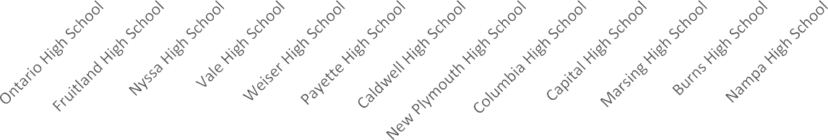
5

0
5
5
6
6
8
10
Total
10
10
13
20

15
20
20
21
25
28
35

30
35
40
Fall 2018 First Time Students (age 21 and under) and High School
Attended

