TVCC
Persistence and Retention Plan
2020-2021

TABLE OF CONTENTS
TVCC Vision and Mission Statements 3
Our Shared Vision TVCC will be an excellence-driven institution offering quality programs to ensure student success. 3
Our Mission 3
President Young’s Vision 3
TVCC Persistence and Retention Plan 4
Student Success Definition 4
TVCC Student Persistence and Retention Team (2020-21) 4
Discussion of Fall-to-Winter Retention Figures 5
Fall-to-Winter Retention Figures 5
Fall-to-Winter Retention Analysis Highlights 11
Discussion of Fall-to-Fall Retention Figures 13
Fall-to-Fall Retention Figures 13
Fall-to-Fall Retention Analysis Highlights 19
Student Retention Priorities Overview 21
Visibility and Teamwork 21
Learning-Centered Policies and Practices 21
Targeted Interventions 21
Motivational Communications 21
Curriculum and Instruction 21
Next Steps for continued development of Retention & Persistence Plan 22
TVCC Student Persistence and Retention Initiatives and Goals 23
Bibliography 24

TVCC Vision and Mission Statements

Our Shared Vision
TVCC will be an excellence-driven institution offering quality programs to ensure student success.

Our Mission
TVCC is a comprehensive community college dedicated to promoting student success.

President Young’s Vision
Make TVCC the First Choice for students; focus on enrollment growth strategies; increase efforts to promote a positive college public image; advance internal communication and connections; cultivate diversity and cultural opportunities; and promote safety and security across campus.

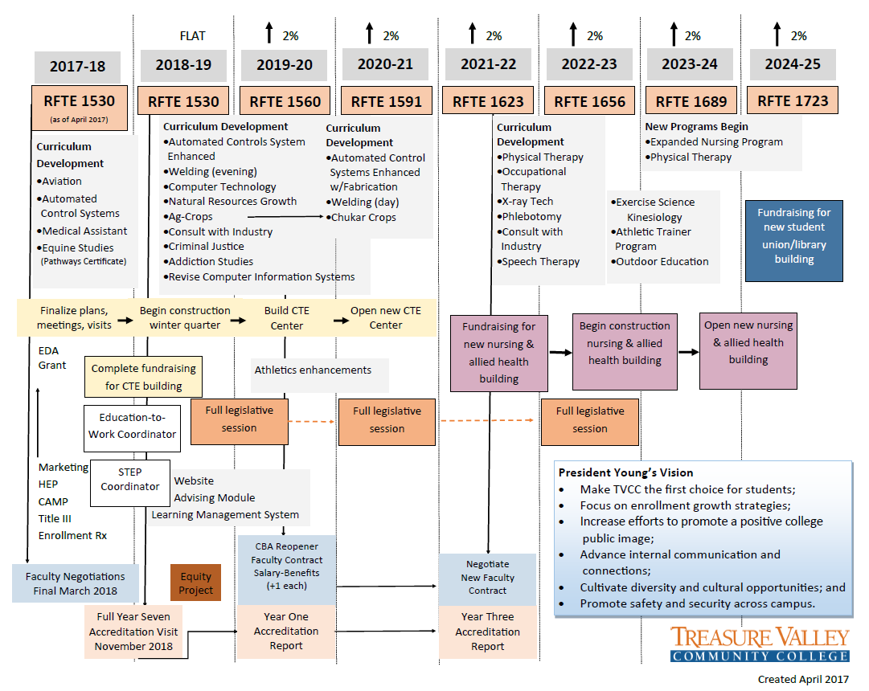
Figure 1. President Young's Vision.

TVCC Persistence and Retention Plan
This Persistence and Retention Plan supports President Young’s Vision. In this Vision (see Figure 1), many activities are aligned with an increase in student enrollments. The enrollment objective is to begin increasing the Reimbursable Full-Time Equivalent (RFTE), in 2019-20 by 2%, and an additional 2% each subsequent year, through 2024-25. While these enrollments are likely to come from new students with the building of the new CTE Center and programmatic growth, a portion of the RFTE must come from improvements to retention. As such, this plan assists in this particular objective.

Retention refers to the number of students who enroll for their first year, and then subsequently enroll in the next term (Fall-to-Winter retention) or the next year (Fall-to-Fall retention). Persistence refers to the number of students who continue to pursue their educational goal.

Student Success Definition
TVCC’s PRP defines student success as a sequential series of goal attainment, starting with course completion, followed by persistence, retention, and culminating in the student’s individual academic goal. The PRP mission is to increase the rates of student completion and/or educational goal attainment at TVCC through a specific, ambitious, and data-informed Student Retention Plan.

TVCC Student Persistence and Retention Team (2020-21)
Eddie Alves – Vice President of Academic Affairs (AA)
Wayne Fischer-Student Success Coordinator (Title III)
Brad Hammond – Vice President of Student Services (SS)
David Koehler – Dean of Career and Technical Education (CTE)
Miguel Lopez – Director of Institutional Effectiveness and Planning (IR)
Travis McFetridge – Director of Admissions and Student Success (SS)
Yumiyo Okuda– Data Analyst (IR)
Faculty Involvement – TBD (Enrollment Committee)

Discussion of Fall-to-Winter Retention Figures
It should be noted that the data visualizations developed for the initial TVCC Persistence-Retention Plan are based on the IPEDs Cohort of students (ten year average of Cohorts: n =354 students). To be included in this Cohort, students must be:
- First-time in College (no previous experience as a college student, after high-school graduation);
- Degree- or certificate-seeking;
- Entering-in-Fall term (cannot have started at TVCC in any term other than Fall or the Summer term preceding their entering Fall term); and
- Full-time (enrolled for 12 or more quarter credits during their entering Fall term).

A student would be counted as “retained” ONLY IF the student was:
- enrolled for credit in the subsequent Winter term; or
- completed a degree or certificate by the subsequent Winter term.

Fall-to-Winter Retention Figures

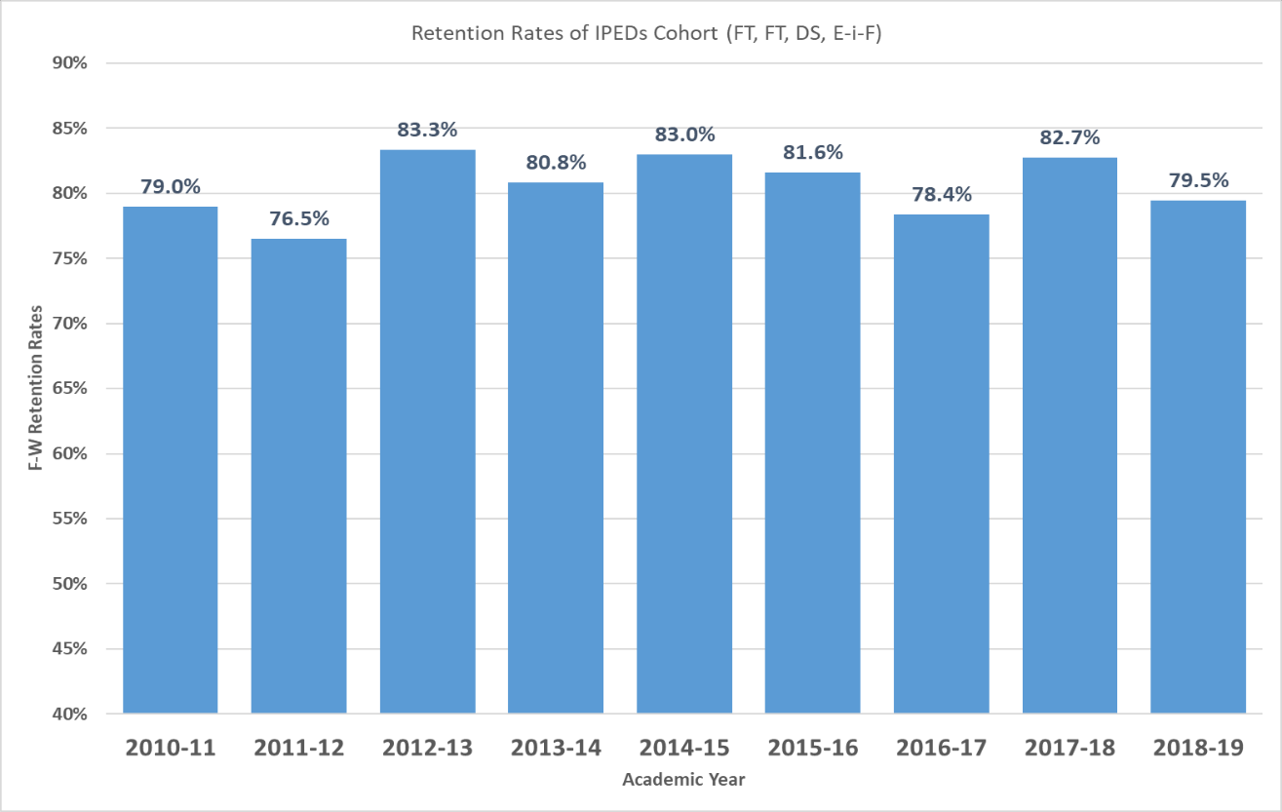
Figure 2. Fall-to-Winter Retention Rates, by Academic Year.

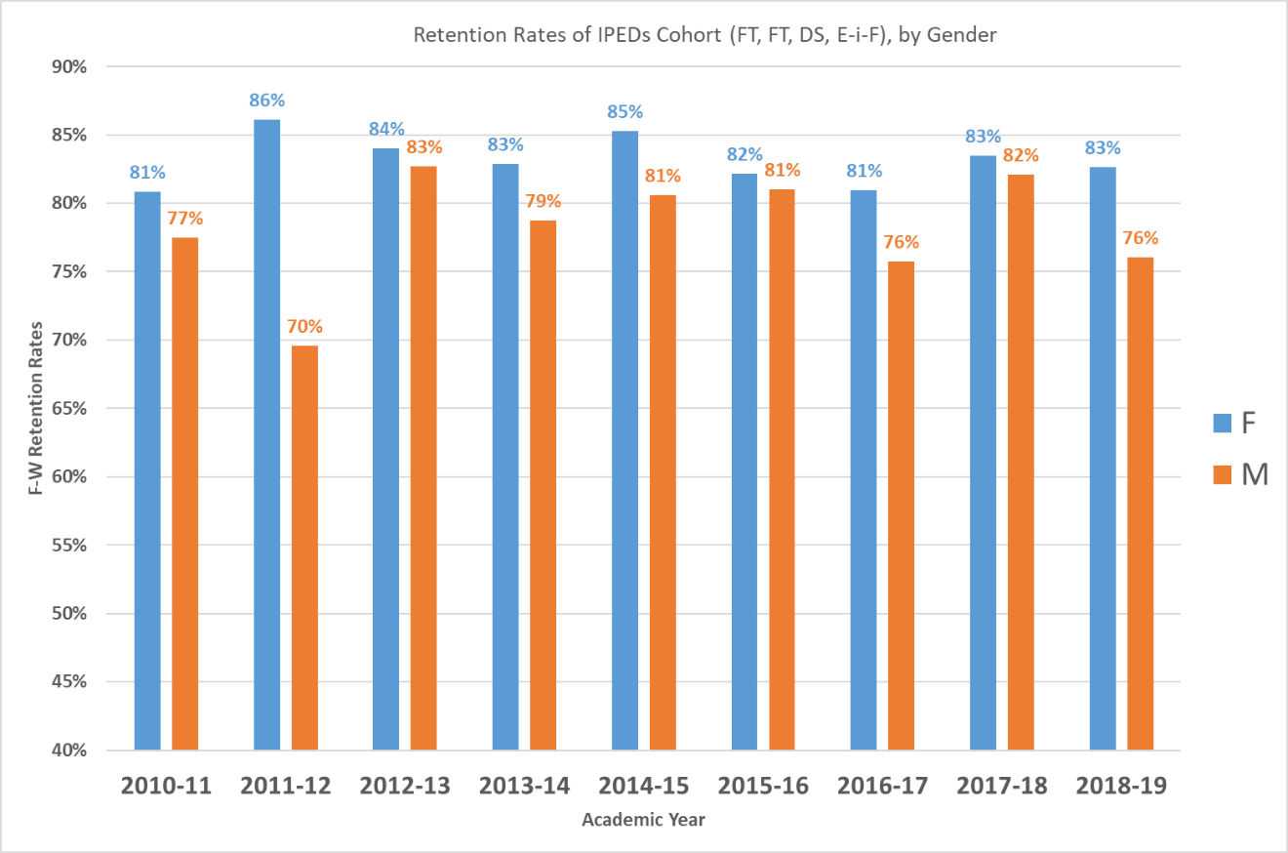
Figure 3. Fall-to-Winter Retention, by Gender and Academic Year

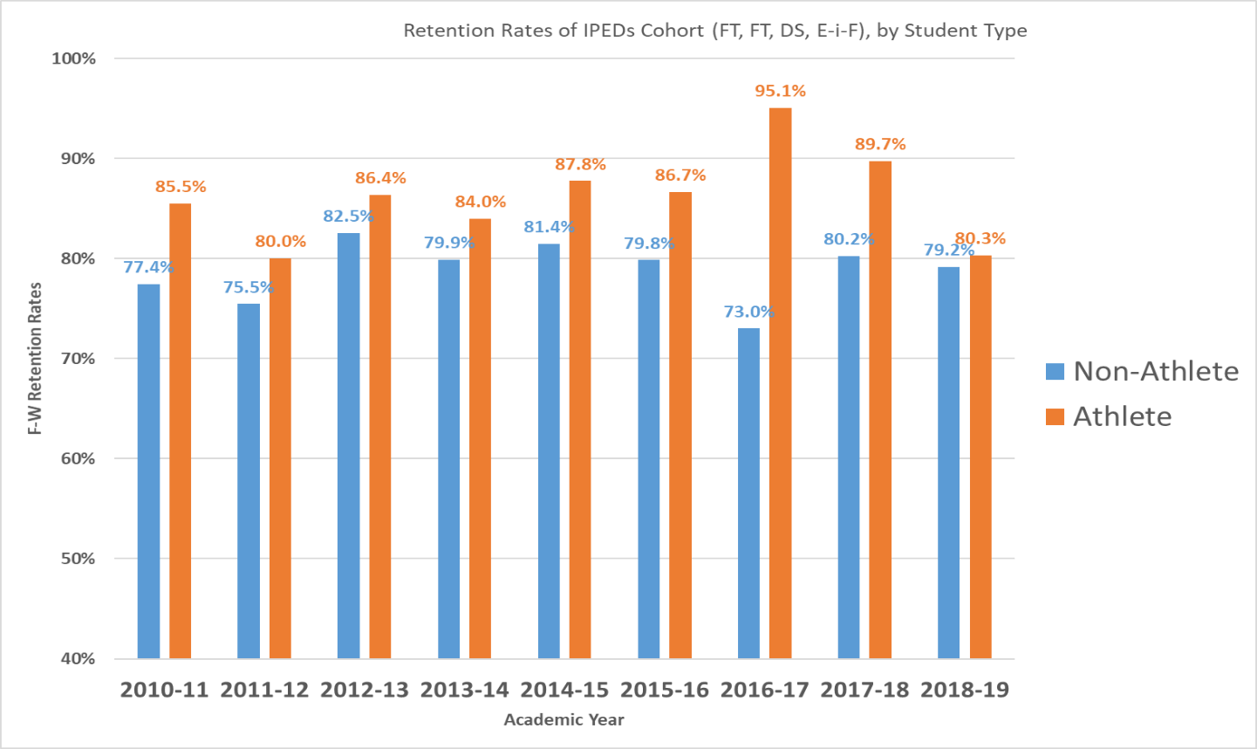
Figure 4. Fall-to-Winter Retention, by Student Athlete and Academic Year

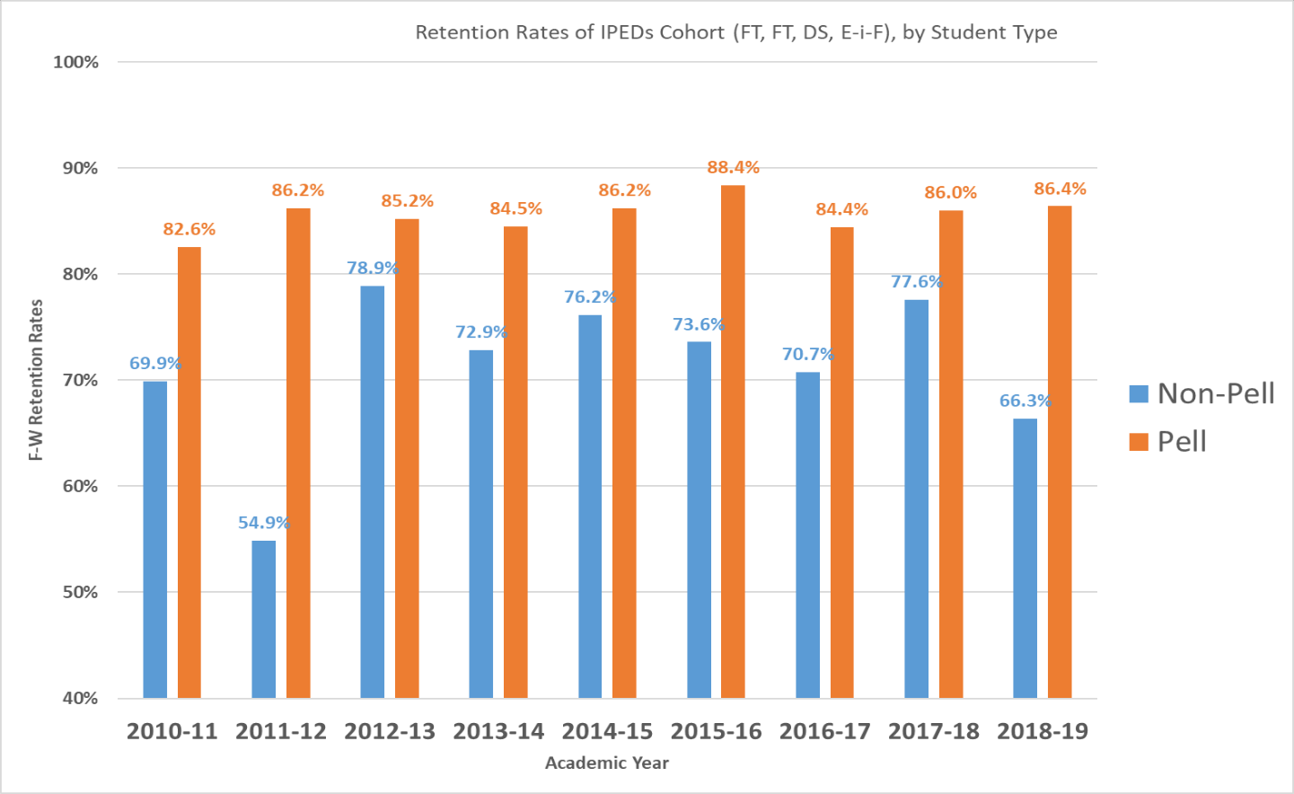

Figure 5. Fall-to-Winter Retention, by Pell Status and Academic Year.
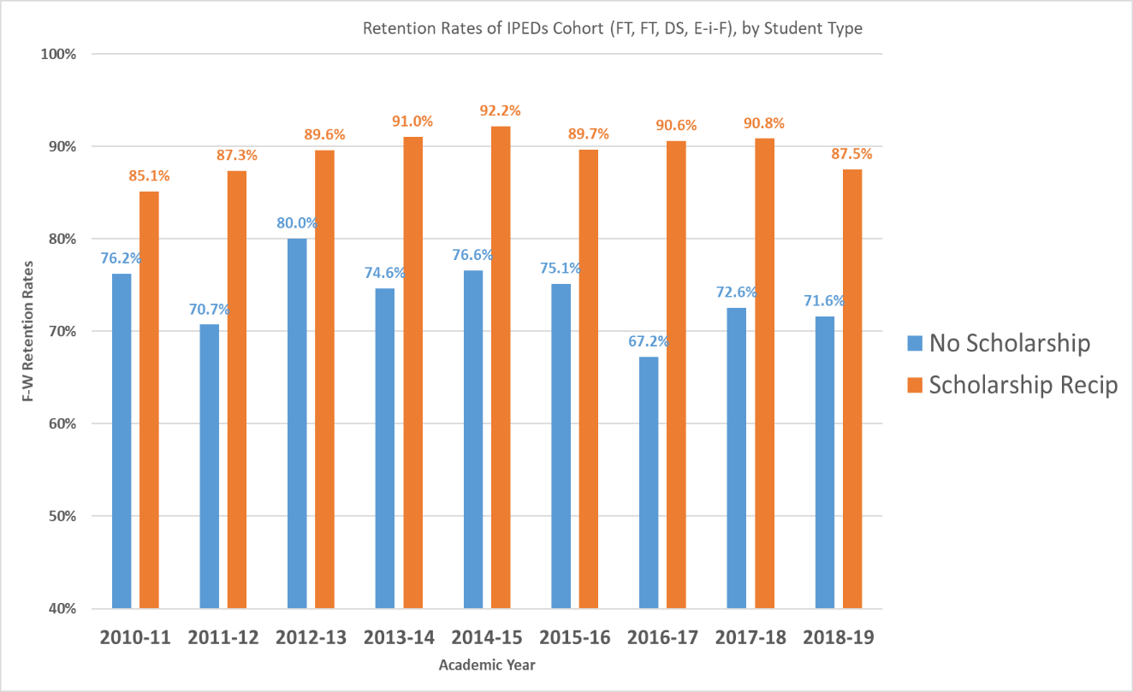

Figure 6. Fall-to-Winter Retention, by Scholarship Status and Academic Year.

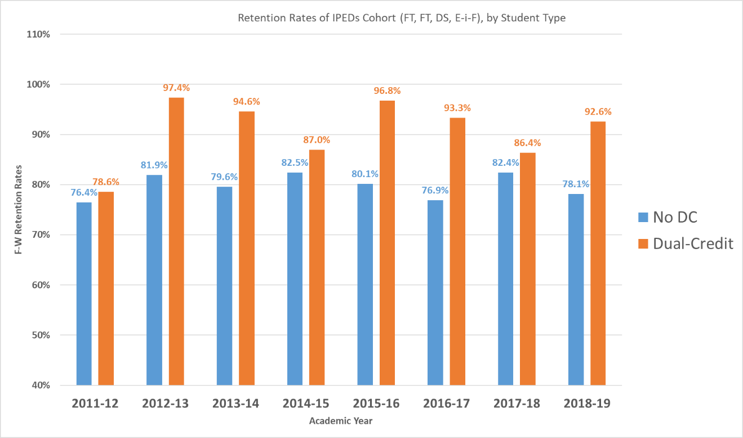

Figure 7. Fall-to-Winter Retention, by Dual-Credit Student and Academic Year.

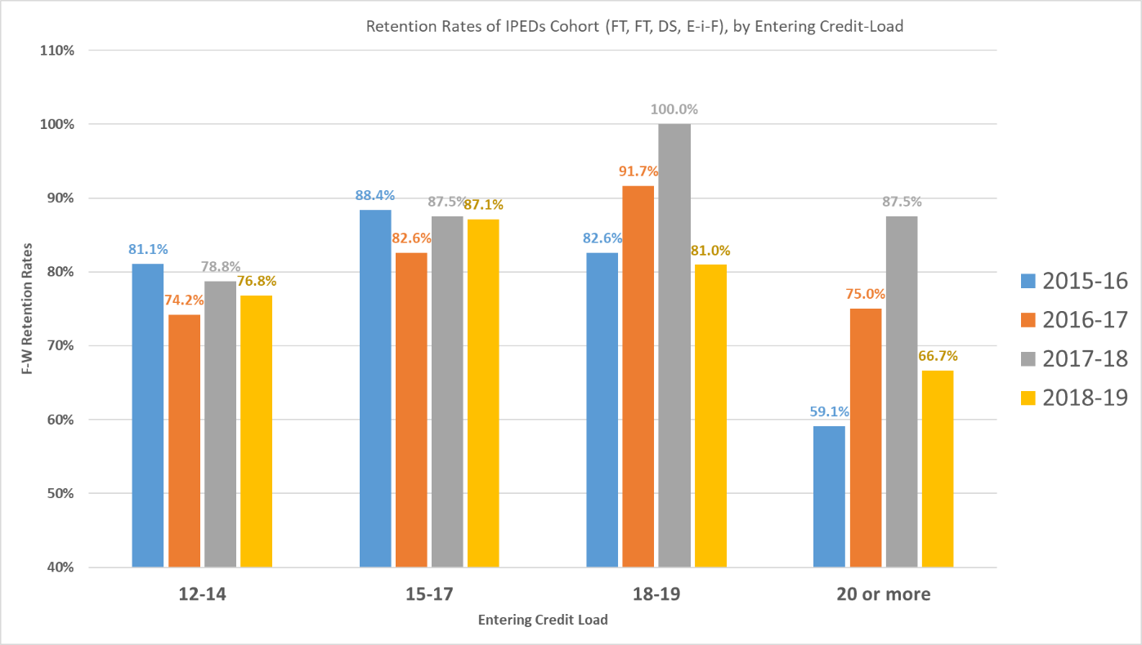

Figure 8. Fall-to-Winter Retention, by Entering Credit Load (Fall) and Academic Year.

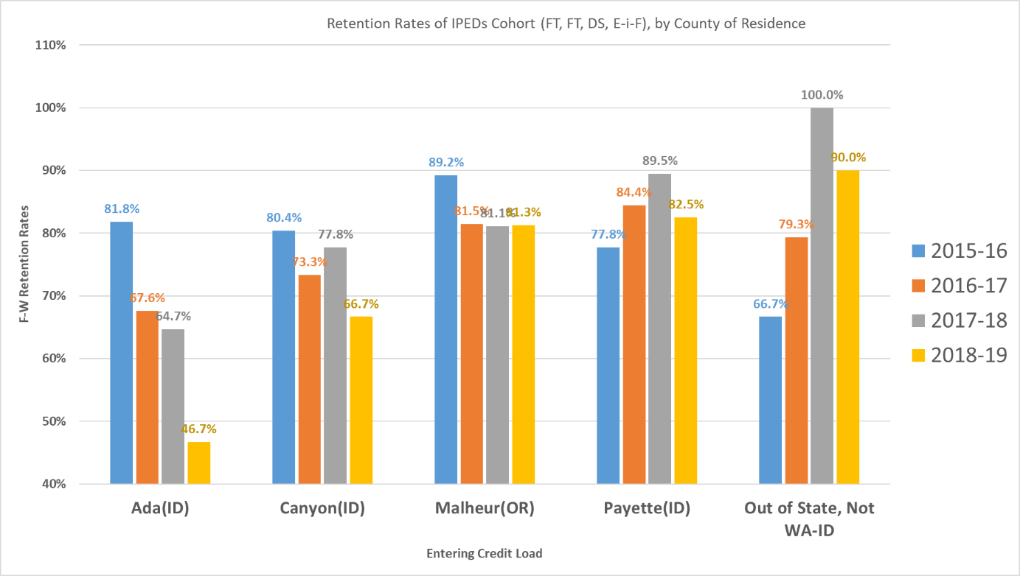

Figure 9. Fall-to-Winter Retention, by County of Residence and Academic Year.
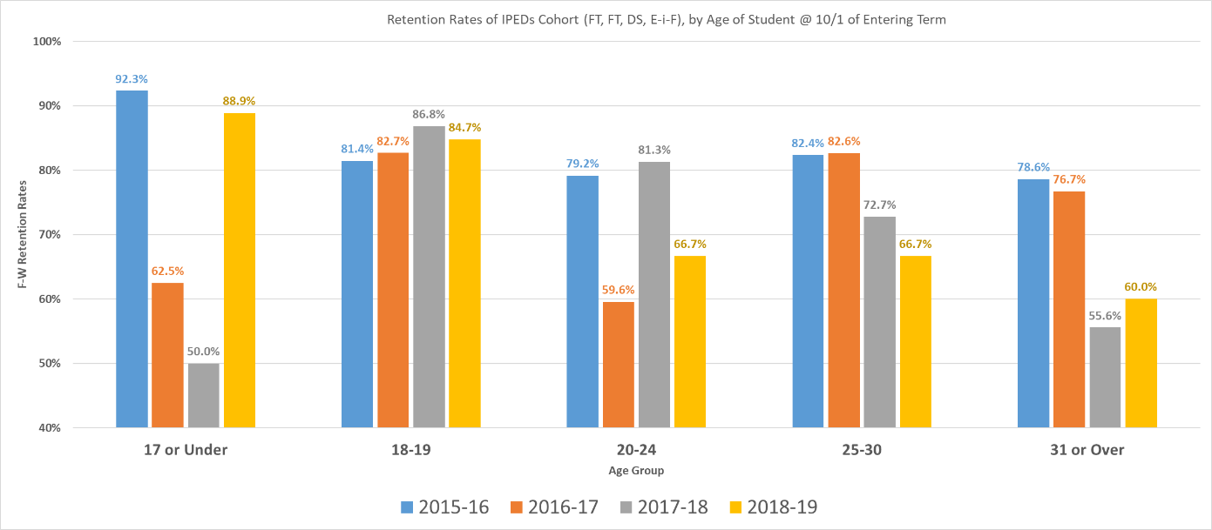

Figure 10. Fall-to-Winter Retention, by Age Group on October 1st of Entering Year and Academic Year.

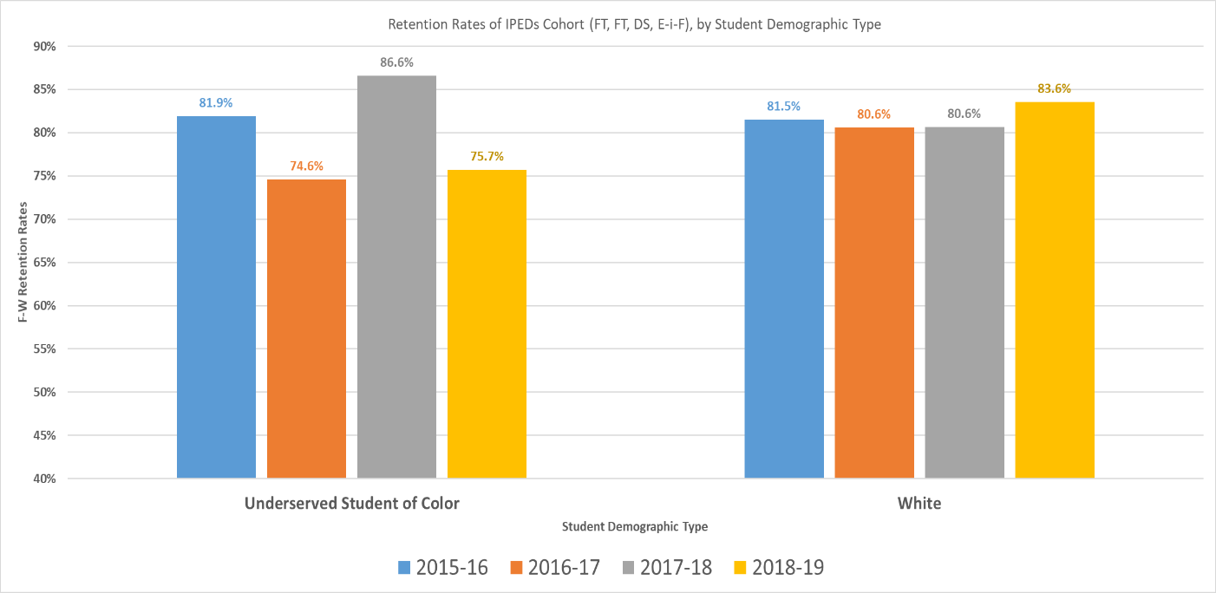
Figure 11. Fall-to-Winter Retention, by Underserved Student of Color vs. White on October 1st of Entering Year.
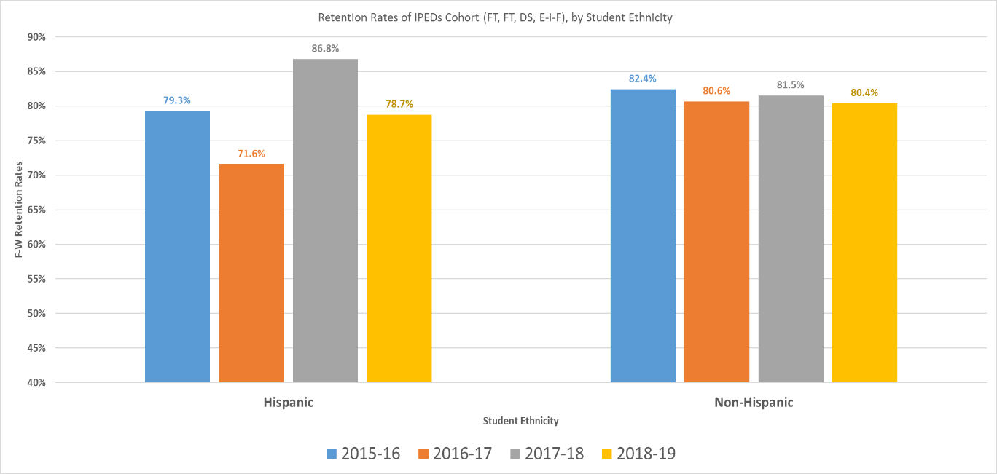
Figure 12. Fall-to-Winter Retention, by Hispanic vs. Non-Hispanic on October 1st of Entering Year.

Fall-to-Winter Retention Analysis Highlights
- Fall-to-Winter Retention has been fairly consistent, over the last nine years, hovering around 80%.
- The most recent year, 2018-19, shows an 80% retention rate for the IPEDs Full-time Cohort, which was down from 83% the prior year, a year-to-year decline of -3.6%.
- Spanning nine years, the 2011-12 academic year had the lowest retention (76.5%), followed by the 2016-17 academic year, which had the second-lowest Fall-to-Winter retention (78.4%).
- The highest retention rate (83.3%) across these nine years was achieved in 2012-13, followed by the second highest at 83.0%, achieved in both 2014-15 and 2017-18.
- Female student in the IPEDs Cohort are generally retained at higher levels than their male counterparts.
- Athletes have typically been retained at higher rates than non-athletes.
- In 2016-17, athletes were retained from Fall-to-Winter, at 95.1%, compared to only 73% for their non-athlete counterparts. This year had the largest disparity in Fall-to-Winter retention rates between the two groups.
- Pell recipients are typically retained from Fall-to-Winter at noticeably higher rates than non-Pell recipients.
- Scholarship recipients are typically retained from Fall-to-Winter at noticeably higher rates than non-scholarship recipients. TVCC needs a deeper-dive into this data, to find out the retention of scholarship recipients by 1) dollar amount; and 2) entering credit load.
- Previous dual-credit students are typically retained from Fall-to-Winter at noticeably higher rates than non-dual-credit students.
- The Fall-to-Winter retention rates are noticeably higher for students who have entering-in Fall credit loads between 15-17 and 18-19, than those students whose Fall credit loads are between 12-14 or 20 or more. The sweet spot seems to be somewhere between 15-19.
- Fall-to-Winter retention has continually declined for students in the IPEDs Cohort who have permanent addresses in Ada County.
- For students in the IPEDs Cohort who have permanent addresses in Malheur and Payette counties, Fall-to Winter retention has been fairly consistent.
- For students in the IPEDs Cohort who have permanent addresses in Canyon County, Fall-to-Winter retention dropped last year, in 2018-19, to its lowest in four years (66.7%).
- For students in the IPEDs Cohort who have permanent addresses outside of Oregon, Washington, and Idaho, the Fall-to-Winter retention rates has increased.
- For students in the IPEDs Cohort who are in the 18-19 age group (on October 1st of their Entering-in-Fall year), these students have the most consistent Fall-to-Winter retention rates. The rates for this group have actually increased a bit over the past four years.
- The 25-30 age group is the next most consistent, although has been trending downwards.
- The Fall-to-Winter retention of Underserved Students of Color has been up and down, over the last four years. The rate for White students has remained consistent. However, 2017-18 saw higher retention rates for Underserved Students of Color than White students. The data shows similar results for Hispanic vs. non-Hispanic students.

Discussion of Fall-to-Fall Retention Figures
It should be noted that the data visualizations developed for the initial TVCC Retention Plan are based on the IPEDs Cohort of students (ten year average of Cohorts: n =354 students).. To be included in this Cohort, students must be:
- First-time in College (no previous experience as a college student, after high-school graduation);
- Degree- or certificate-seeking;
- Entering-in-Fall term (cannot have started at TVCC in any term other than Fall or the Summer term preceding their entering Fall term); and
- Full-time (enrolled for 12 or more quarter credits during their entering Fall term).

A student would be counted as “retained” ONLY IF the student was:
- enrolled for credit in the subsequent Fall term, the following academic year; or
- completed a degree or certificate by the subsequent Fall term.

Fall-to-Fall Retention Figures

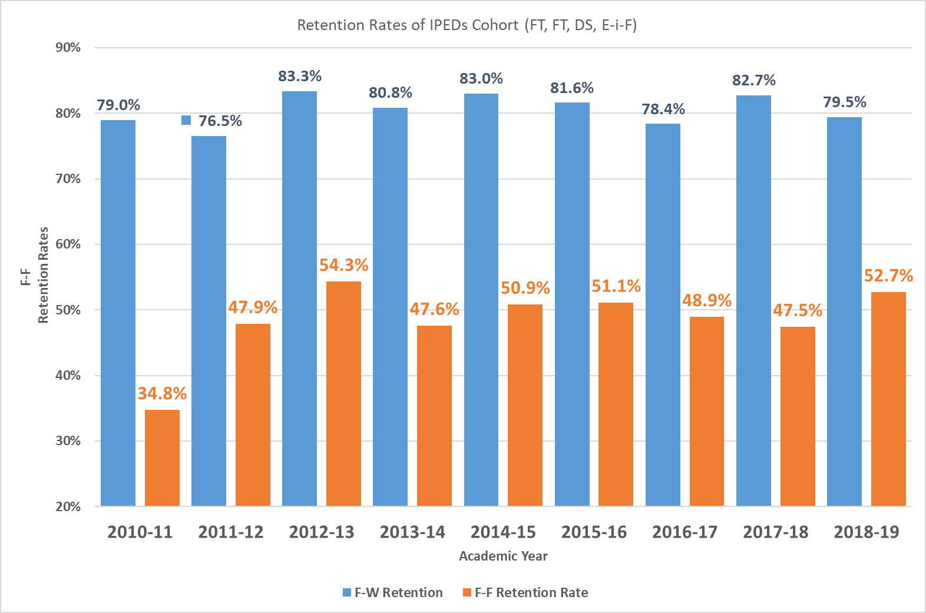
Figure 13. Fall-to-Fall Retention Rates, by Academic Year.

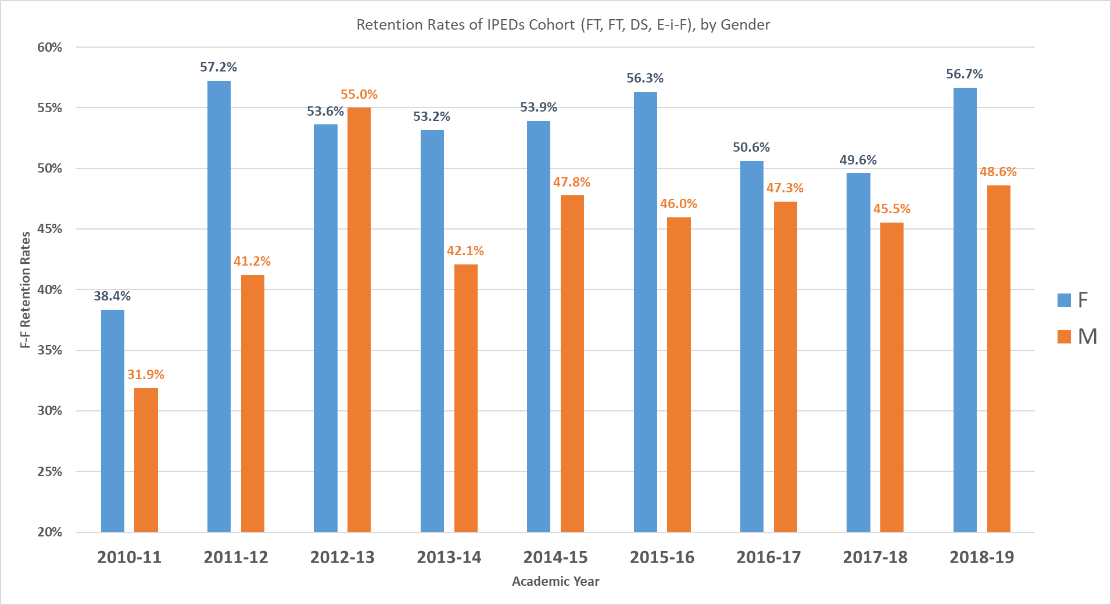
Figure 14. Fall-to-Fall Retention, by Gender and Academic Year.

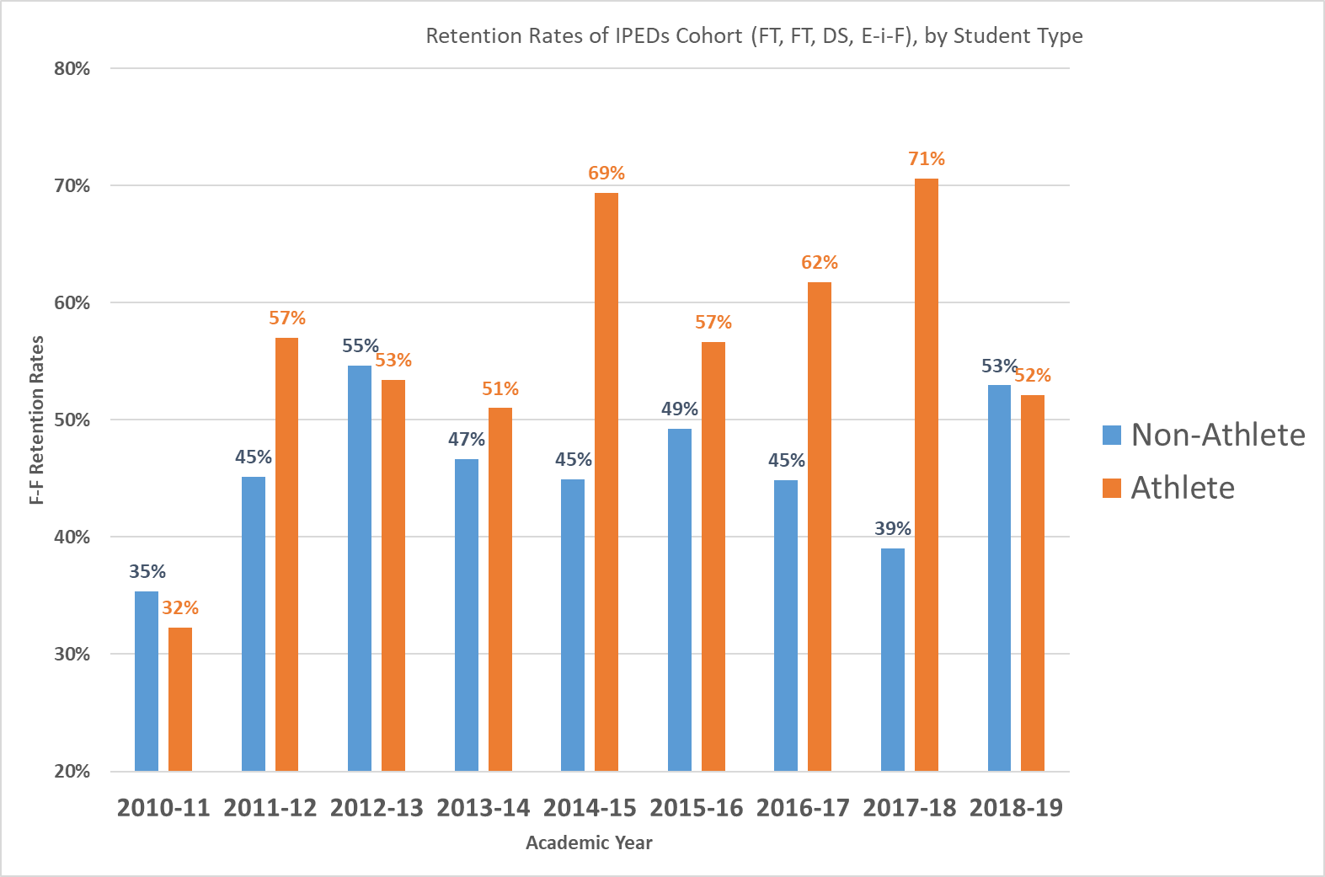
Figure 15. Fall-to-Fall Retention, by Student Athlete and Academic Year
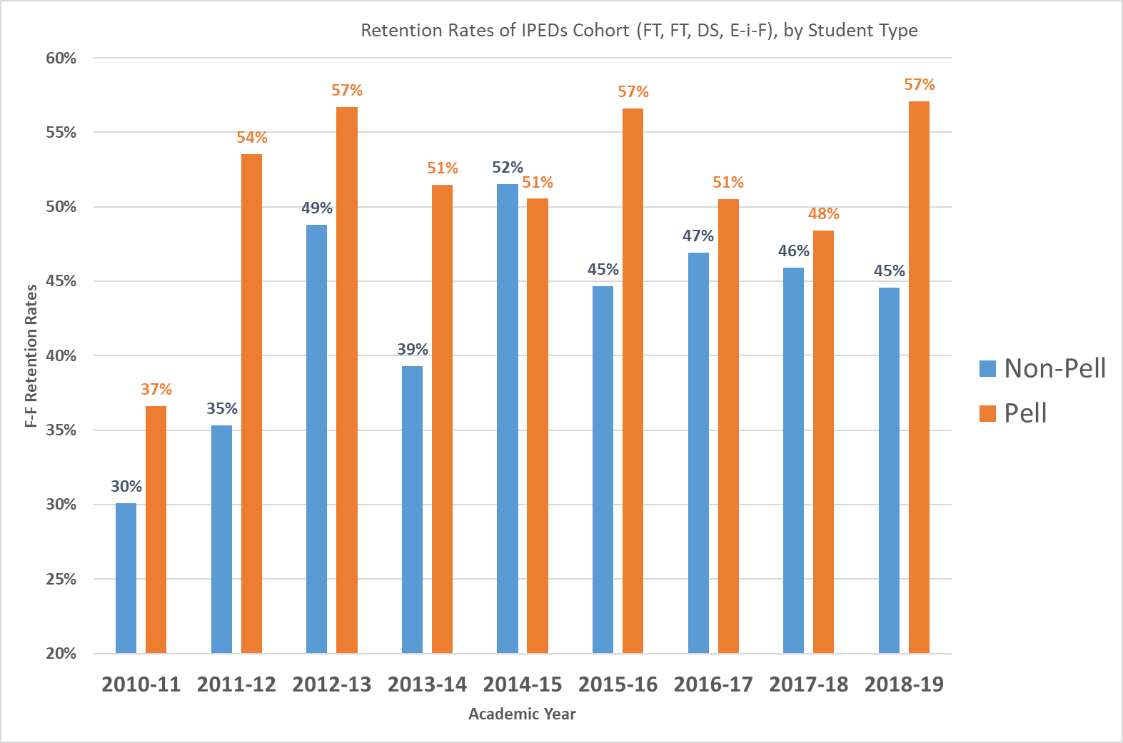
Figure 16. Fall-to-Fall Retention, by Pell Status and Academic Year.
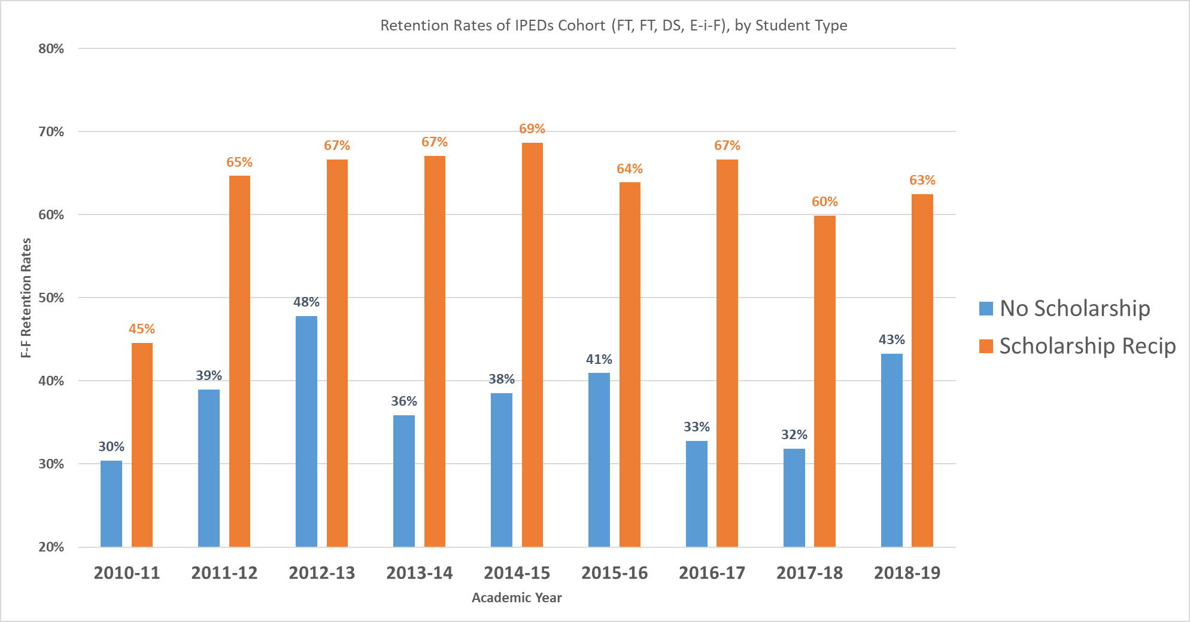
Figure 17. Fall-to-Fall Retention, by Scholarship Status and Academic Year.

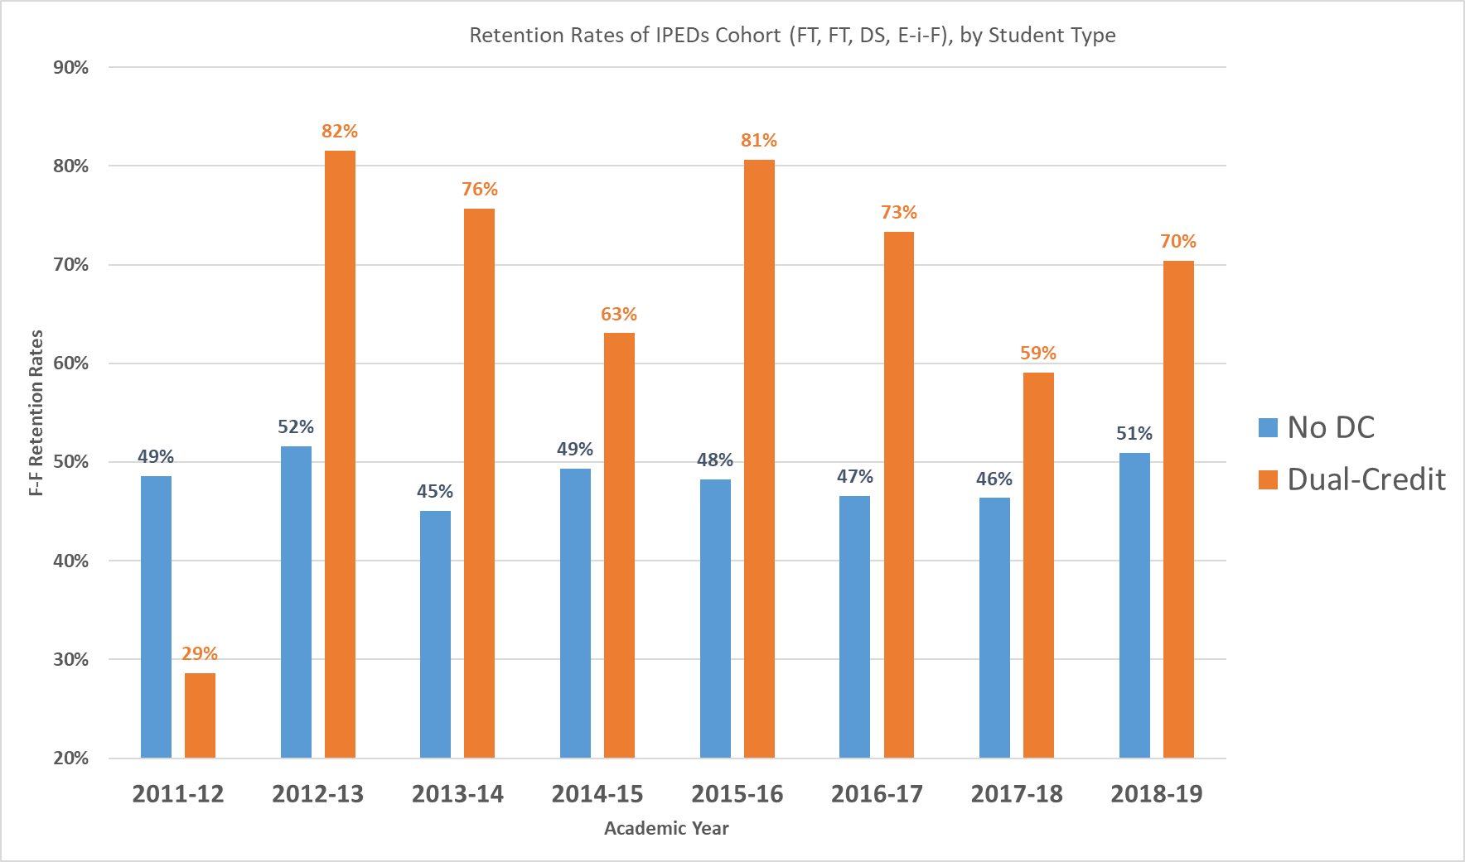
Figure 18. Fall-to-Fall Retention, by Dual-Credit Student and Academic Year.

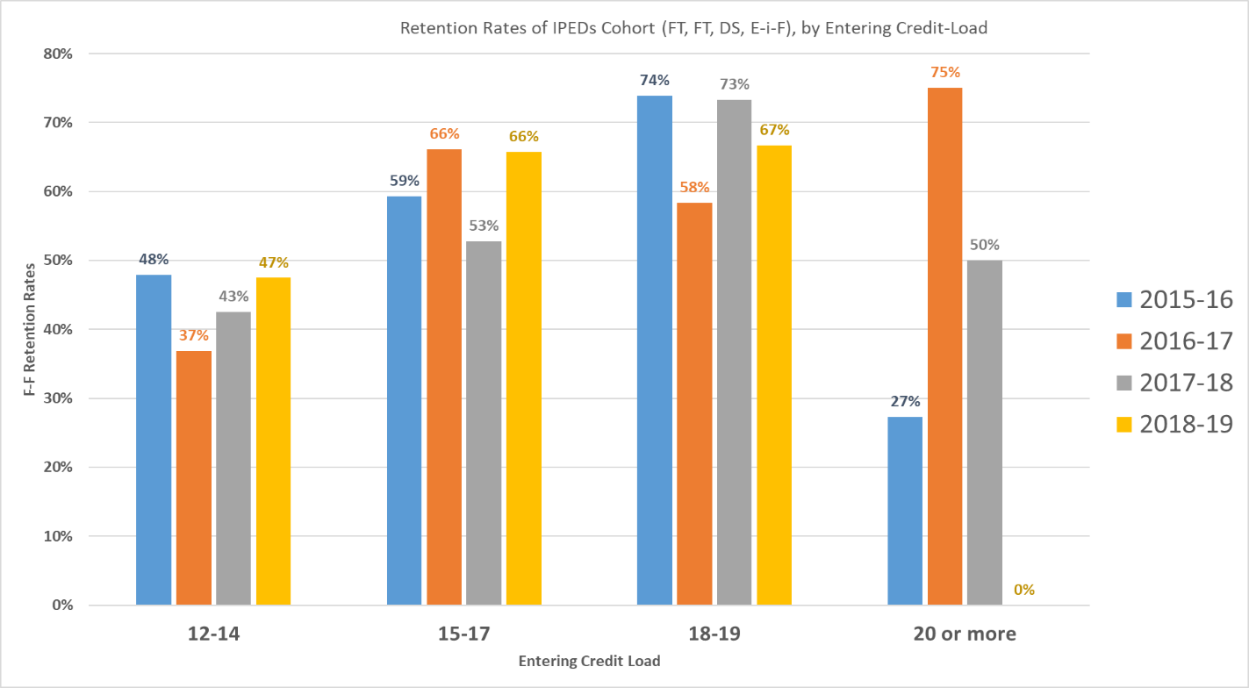
Figure 19. Fall-to-Fall Retention, by Entering Credit Load(Fall) and Academic Year.

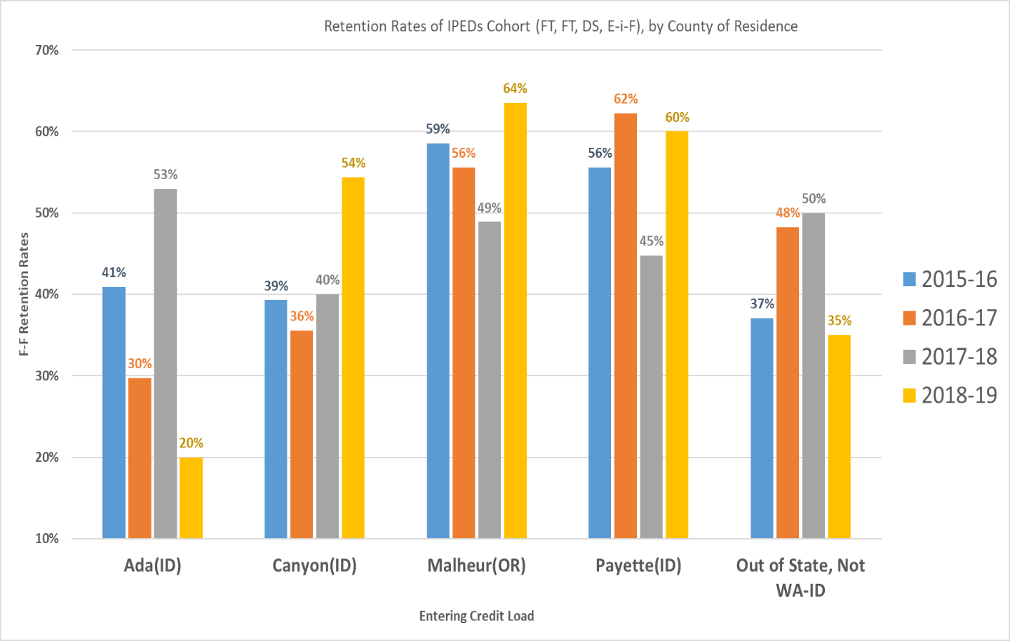
Figure 20. Fall-to-Fall Retention, by County of Residence and Academic Year.

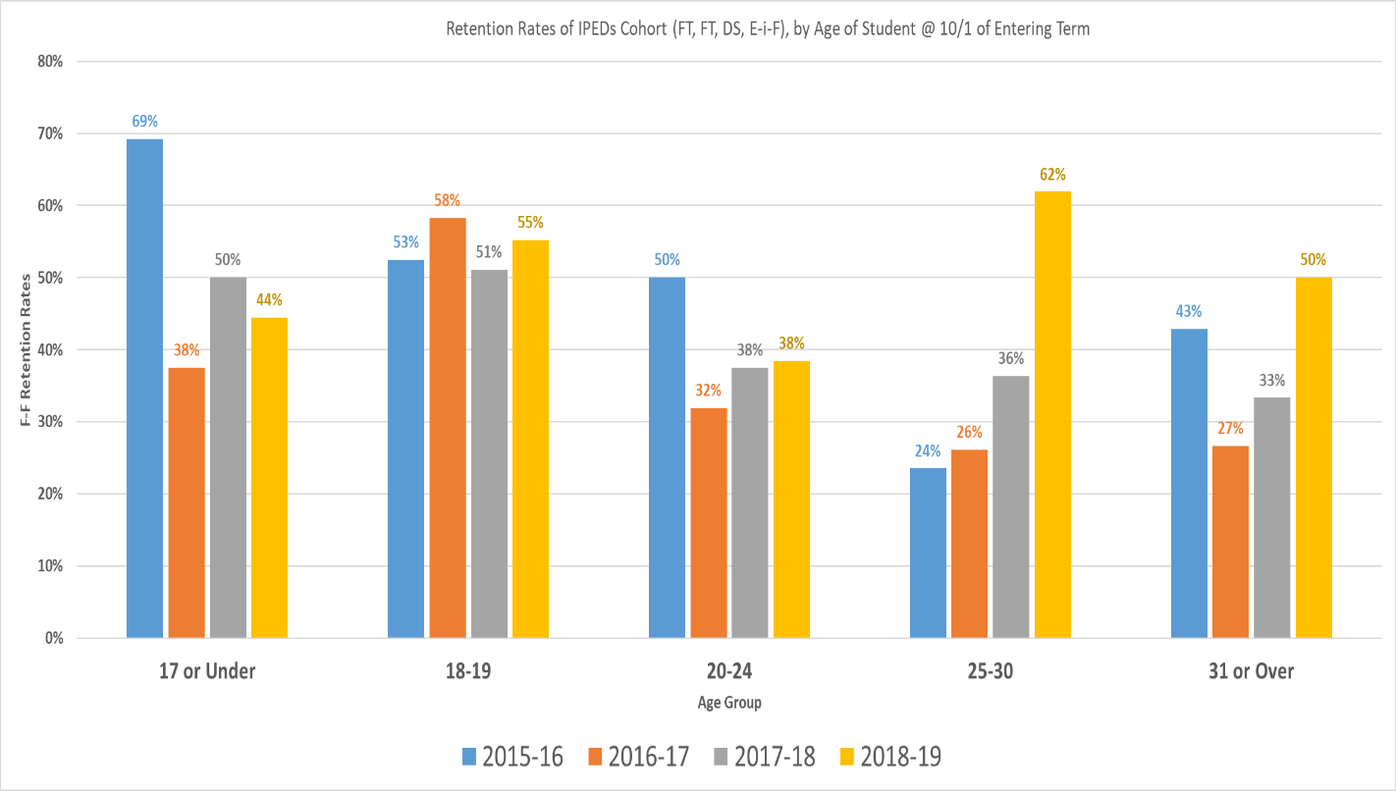
Figure 21. Fall-to-Fall Retention, by Age Group on October 1st of Entering Year and Academic Year.

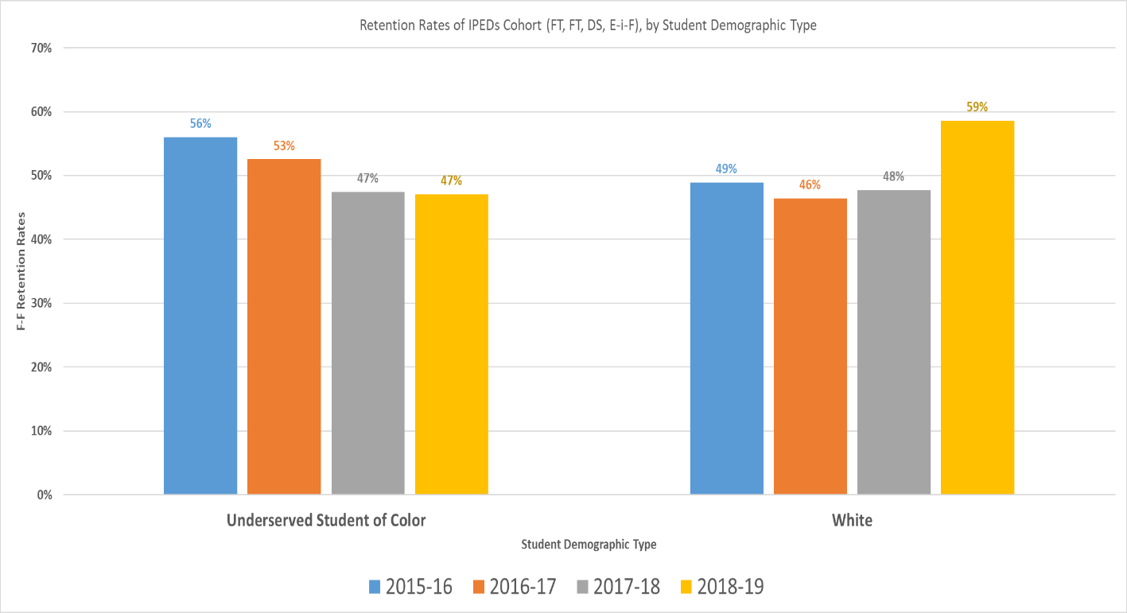
Figure 22. Fall-to-Fall Retention, by Underserved Student of Color vs. White on October 1st of Entering Year.

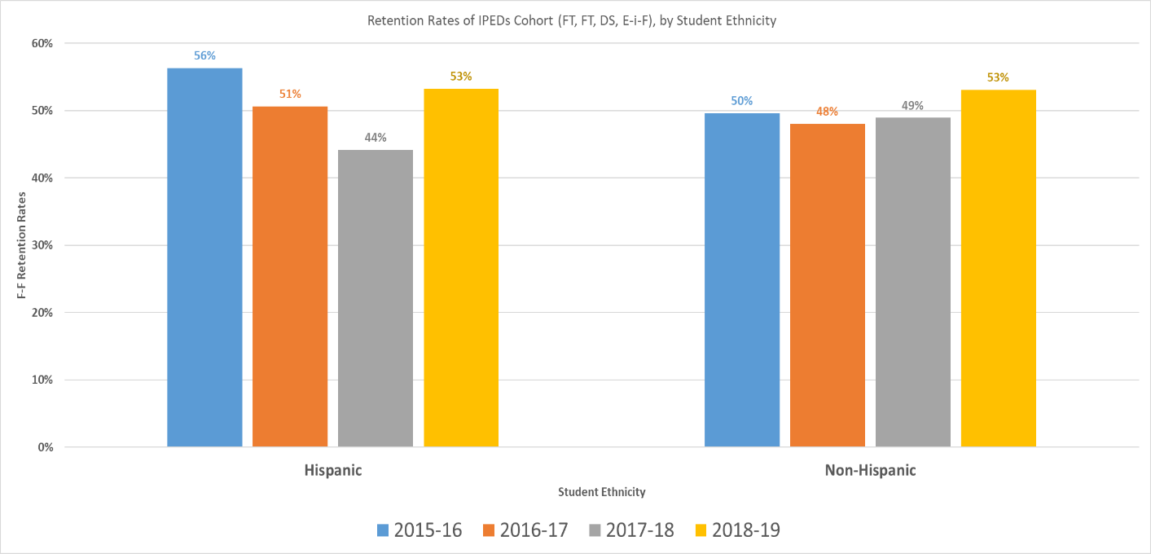
Figure 23. Fall-to-Fall Retention, by Hispanic vs. Non-Hispanic on October 1st of Entering Year.

Fall-to-Fall Retention Analysis Highlights

- The Fall-to-Winter Retention Rate is much higher than the Fall-to-Fall Retention Rate, so we may need to review the Fall-to-Spring rates. A cursory view of the Fall-to-Spring rates show a 10-15% drop.

- An average GPA of students has not been tracked for each term for each cohort of interest. We my want to include this in future data dives.

- Fall-to-Fall Retention has been fairly consistent, over the last nine years, hovering around 50%.

- The most recent year, 2018-19, shows a 52.7% retention rate for the IPEDs Full-time Cohort, which was the highest Fall-to-Fall rate since 2012-13.

- Spanning nine years, the 2010-11 academic year had the lowest retention (34.8%), followed by the 2017-18 academic year, which had the second-lowest Fall-to-Fall retention (47.5%).

- The highest retention rate (54.3%) across these nine years was achieved in 2012-13, followed by the second highest at 52.7%, achieved in 2018-19. Title III grant (focused on retention) began in 2016-17.

- Female student in the IPEDs Cohort are generally retained at higher levels than their male counterparts, following Fall-to-Winter retention rates.

- Athletes have typically been retained at higher rates than non-athletes. However, in 2018-19, athletes were retained at about the same rate.

- Pell recipients are typically retained from Fall-to-Fall at noticeably higher rates than non-Pell recipients. Again, this follows Fall-to-Winter rates.

- Scholarship recipients are typically retained from Fall-to-Fall at noticeably higher rates than non-scholarship recipients. In fact, the data shows that the retention discrepancy between scholarship recipients and non-recipients is greater in Fall-to-Fall than Fall-to Winter. TVCC needs a deeper-dive into this data, to find out the retention of scholarship recipients by 1) dollar amount; 2) entering credit load, and 3) continuing credit load.

- Previous dual-credit students are typically retained from Fall-to-Fall at noticeably higher rates than non-dual-credit students. In fact, the data shows that the retention discrepancy between prior dual-credit students and non-dual credit students is greater in Fall-to-Fall than Fall-to Winter.

- The Fall-to-Fall retention rates are noticeably higher, and noticeably more consistent, for students who have entering-in-Fall credit loads between 15-17 and 18-19, than those students whose Fall credit loads are between 12-14 or 20 or more. The sweet spot seems to be somewhere between 15-19.

- Fall-to-Fall retention has continually declined for students in the IPEDs Cohort who have permanent addresses in Ada County, with the exception of 2017-18.

- For students in the IPEDs Cohort who have permanent addresses in Malheur and Payette counties, Fall-to Fall retention has been fairly consistent. 2017-18 was lower for these two counties.

- For students in the IPEDs Cohort who have permanent addresses in Canyon County, Fall-to-Fall retention increased last year, in 2018-19, to its highest in four years (66.7%). This is contrary to the Fall-to-Winter rates for those students who have permanent addresses in Canyon County.

- For students in the IPEDs Cohort who have permanent addresses outside of Oregon, Washington, and Idaho, the Fall-to-Fall retention rates has increased, with the exception of 2018-19. This follows the same pattern of the student athletes vs. non-athletes.

- For students in the IPEDs Cohort who are in the 18-19 age group (on October 1st of their Entering-in-Fall year), these students have the most consistent Fall-to-Fall retention rates, similar to the Fall-to-Winter consistency.

- The 25-30 age group, contrary to the Fall-to-Winter retention for this group, has been trending upwards.

- Fall-to-Fall retention has decreased, slightly, for Underserved Students of Color, over the last four years. Over the last four years, Underserved Students of Color were retained, Fall-to-Fall, at higher rates than White students, in 2015-16 and 2016-17. The last two years (2017-18 and 2018-19), White students were retained higher than Underserved Students of Color. The same pattern is true for Hispanic vs. non-Hispanic students.

Student Retention Priorities Overview

Visibility and Teamwork
Priority 1.0: Retention, completion, and student success initiatives are prioritized within the college community. Faculty, staff, and students value student success and are engaged in a continuous process of data-informed improvement to meet shared goals.
- Include in TVCC’s data dashboard system, retention rates of different student groups.
- Include in TVCC’s data dashboard system, completion rates of gateway courses.

Learning-Centered Policies and Practices
Priority 2.0: Revise and/or create learning-centered policies which align with institutional goals of student success and goal/degree completion.
- “15-to-Finish”: Implement a practice of Academic Advising so that the entering credit-load of students is between 15-18 credits for full-time, entering-in-Fall, first-time college students.

Targeted Interventions
Priority 3.0: Existing resources will be strategically deployed using a data-informed decision making process, and in the absence of resources in the face of student need, new interventions to support students will be developed.
- Increase communication of offerings to High School students AND increase recruitment of these students (informs the recruitment mgmt. plan).
- Targeted recruitment and retention messaging for first-generation college students and Pell-grant recipients and students, such as financial literacy components and FAFSA workshops (informs the recruitment mgmt. plan)

Motivational Communications
Priority 4.0: Intentional communications with students maintain and support continuous enrollment and student success.
- Develop and share retention and success data/factors to students so that their first-year experience emphasizes connected learning and encourages student engagement.

Curriculum and Instruction
Priority 5.0 Faculty will have the opportunity to redesign curriculum and instruction to integrate Active Learning Strategies and Student Success Skills that engage students in the learning process and improve student retention.
- TBD. This will be updated by individual faculty and academic departments during the year, to document such initiatives, and to be used in future iterations of the plan.

Next Steps for continued development of Retention & Persistence Plan
Future iterations of this Retention Plan will consider adding additional cohorts of students, in order to better track retention at TVCC. For example, we would like to include:
- Entering-in-Fall-at-TVCC students who are enrolled for 6 or more quarter credits (next year’s plan).
- Cohorts from the Voluntary Framework for Accountability (VFA), a reporting system that is designed specifically for two-year colleges (IPEDS was originally designed to track completion rates at four-year institutions). As such, the VFA uses a different definition for the cohorts that are tracked (future retention plans).

In addition to the expanded cohorts to view retention at TVCC, future Retention Plans will also expand the data visualizations, to include analyses of:
- retention by program (next year);
- retention of students passing gateway courses, such as Math and Writing (next year);
- retention of first-generation college students (next year);
- retention of future transfer students (future years);
- retention of non-degree students (future years); and
- retention of students in transition (future years).

Finally, we would like to increase faculty involvement for the retention plan.

TVCC Student Persistence and Retention Initiatives and Goals

 | Strategic Objective Addressed
Strategic Retention Initiatives/Goals | 1.0 Visibility and Teamwork | 2.0 Learning-Centered Policies and Practices | 3.0 Targeted Interventions | 4.0 Motivational Communications | Target Completion Date | Completed?

Bibliography

Fretwell, G. (2019, July). Student Success: A Shared Responsibility. Presentation at the annual Ruffalo Noel Levitz Conference in Nashville, TN.

Fretwell, G. (2019, October). Treasure Valley Community College Student Success Discovery: Recommendations and points to prioritize for focus in coming year. Site visit on October 17th, 2019.

The Persistence Perspective on Retention. (2019). Retrieved March 5th 2020 from https://get.vitanavis.com/assets/resources/VitaNavis%20-%20Whitepaper%20-%20Persistence%20Retention.pdf

Tinto, V. (2017). Reflections on Student Persistence. Student Success, 8(2), 1-8.

