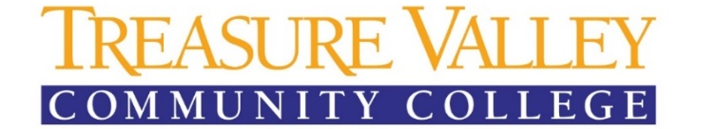

Office of Accessibility and Accommodation Services
P. 541-881-5812 / F. 541-881-5510

Agreement for Recording Lecture and Discussions

Under Section 504 of the 1973 Rehabilitation Act and the American with Disabilities Act, institutions of higher education must provide reasonable accommodations to a student’s known disability and may not deny equal access to the institution’s programs, courses and activities.

Audio recording is a reasonable accommodation for students whose documentation calls for this accommodation. Treasure Valley Community College allows audio recording of lectures when an accommodation letter from the Disability Services Office (DSO) is received by an instructor.

Upon receiving this form, the instructor is encouraged to announce to the class in person and via Blackboard Announcement or Student Email that the lectures for the quarter will be recorded.

Students must notify the instructor/faculty member(s) prior to recording. In addition, due to academic integrity issues relating to the course itself and due to an instructor’s potential copyright in the lectures, qualified students with disabilities who require recording as a reasonable accommodation must sign this agreement before the start of the recording (i.e. before the start of the quarter or when presented with the DSO Accommodation Letter).

I, __________________________________________ (please print) agree that I will not release the recording and/or transcripts, profit financially, or allow others to benefit personally from lectures and discussions I will record in:

Course title and number:

Instructor:

In addition, I will not allow anyone else to listen to or use the audio recording, except for a transcriber who may be required to type it if needed for the accommodation. Further, I will not make copies of the recordings. I understand that a violation of this Agreement may subject me to discipline under The Student Code of Conduct and/or subject me to legal liability.

Student signature: Date:

Instructor signature: Date:

Treasure Valley Community College does not discriminate on the basis of race, color, sex, marital status, sexual orientation, religion, national origin, age or disability in any educational programs, activities or employment. Persons having questions about equal opportunity and nondiscrimination should contact the Human Resources Director located in PAC 105, email HR@tvcc.cc or call 541-881-5838 or TTY 541-881-2723. Treasure Valley Community College is an equal opportunity educator and employer. Revised May 20, 2021.

