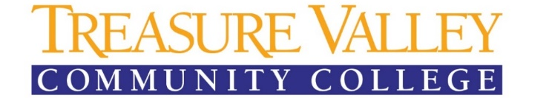
Office of Accessibility and Accommodation Services
P. 541-881-5812 / F. 541-881-5510

Student Request for Academic Accommodations

Please complete the following. This information is used to better serve you and will be held in strict confidentiality. Information from this form will not be included with your academic transcript from Treasure Valley Community College.

Date: TVCC Student I.D. #:

Last Name: First Name: Middle Initial:

Date of Birth:

Mailing Address: City: State: Zip Code:

Home Phone: ( ) Cell Phone: ( )

TVCC Student Email Address:

Currently Attending TVCC: If no, intended enrollment term:

Transfer Student: If yes, from where:

Will you be attending classes? (please circle all those that apply)

Main campus Ontario Caldwell Center Online/Distant Learning

Have you previously received academic accommodations (i.e., grades K-12/IEP or other college/504)?

If yes, please explain:

Please explain/clearly identify accommodations you have had or feel would be beneficial while attending TVCC:

Have you received a diagnosis from a licensed medical professional? ______________. If yes, please list the diagnosis.

*Please note: Treasure Valley Community College, welcomes documentation of an IEP, from K-12, but cannot accept them in leu of medical documentation of said disability. A TVCC Disability Documentation Form must be completed prior to finalizing a 504 or receiving academic accommodations.

Please list an emergency contact:

Name: Relationship:

Preferred phone number:

Signature: Date:

Please do not write below this line – Office of Disability Support Services Use Only

Treasure Valley Community College does not discriminate on the basis of race, color, sex, marital status, sexual orientation, religion, national origin, age or disability in any educational programs, activities or employment. Persons having questions about equal opportunity and nondiscrimination should contact the Human Resources Director located in PAC 105, email HR@tvcc.cc or call 541-881-5838 or TTY 541-881-2723. Treasure Valley Community College is an equal opportunity educator and employer. Revised May 20, 2021.

